Github (algobot_extension.js) Documentation

Move Motor:

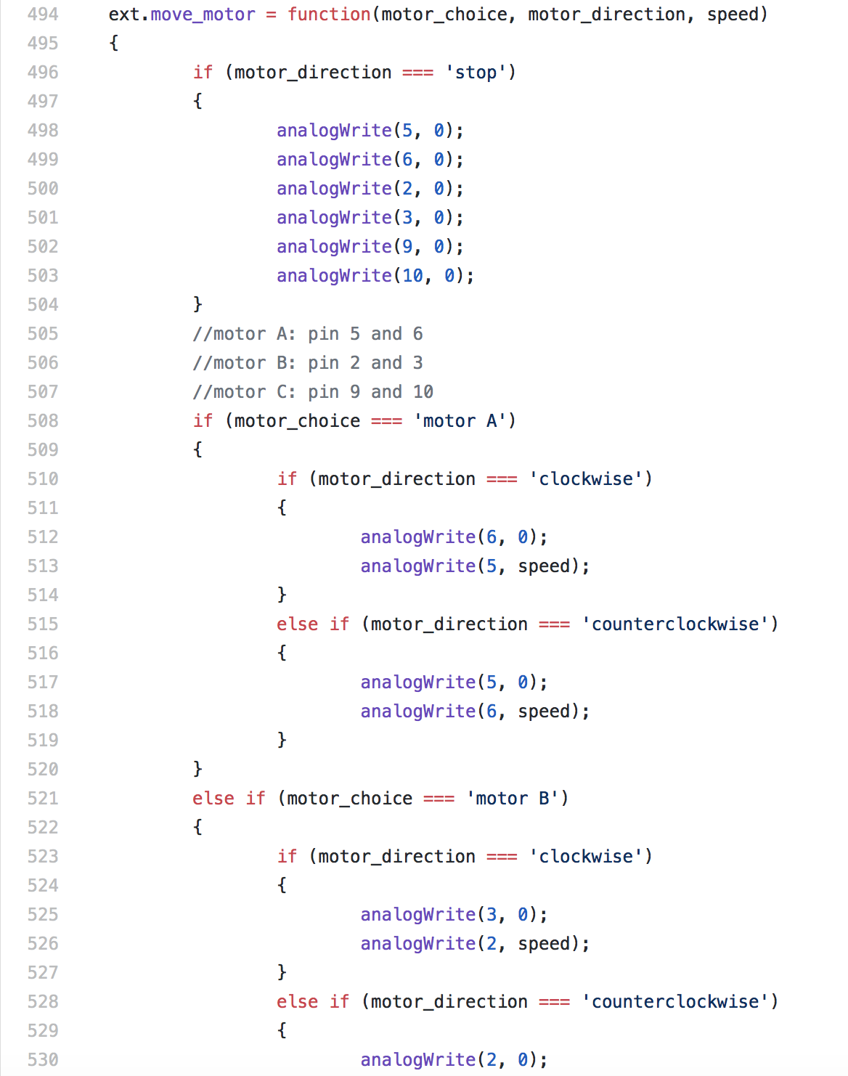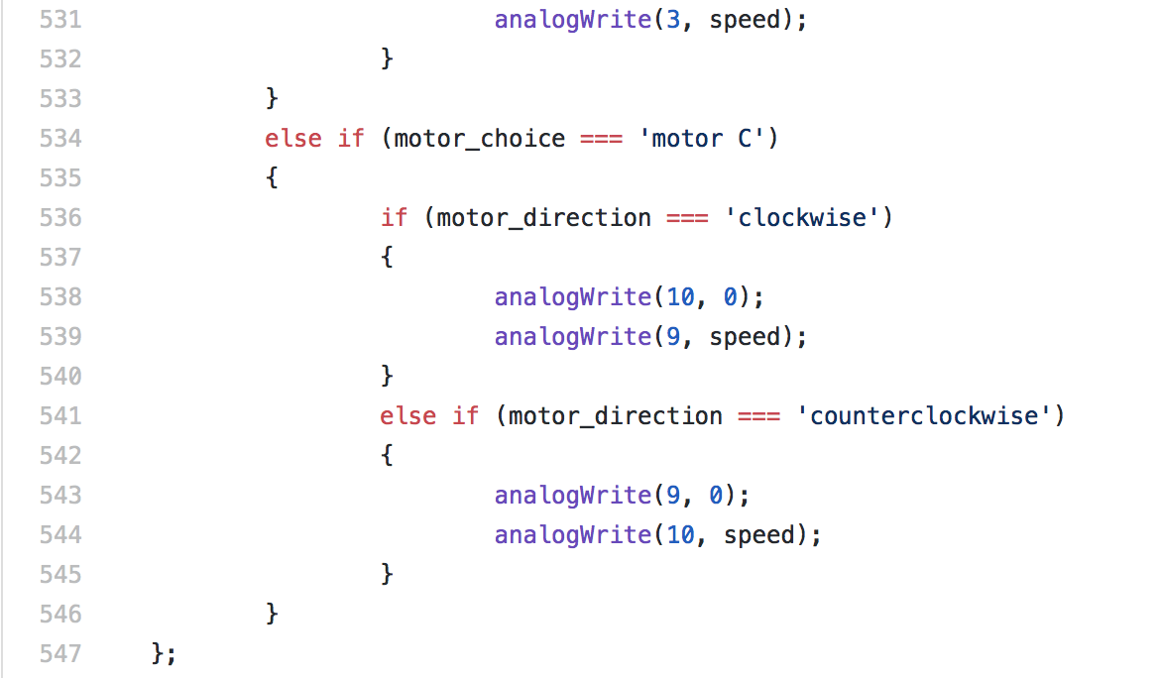

* Function takes 3 inputs from the user, the motor choice, the direction of the motor, and the speed of the motor.



* The motor choice allows the user to pick which motor they want to move. The comments in my code from line 505 to 507 state which pins are connected to each motor. The choices are motor A, motor B, and motor C.
* The motor direction lets the user choose whether they want the motor to turn clockwise, counterclockwise or stop. For this function the motors turn indefinitely until the ‘stop’ choice is picked or the user sets the motor to 0 power.
* The power is based off of the analogWrite function already incorporated into the code. It will turn the motor at a certain speed between the analog 0-255. Numbers <0 will be assigned 0 and >255 are assigned 255

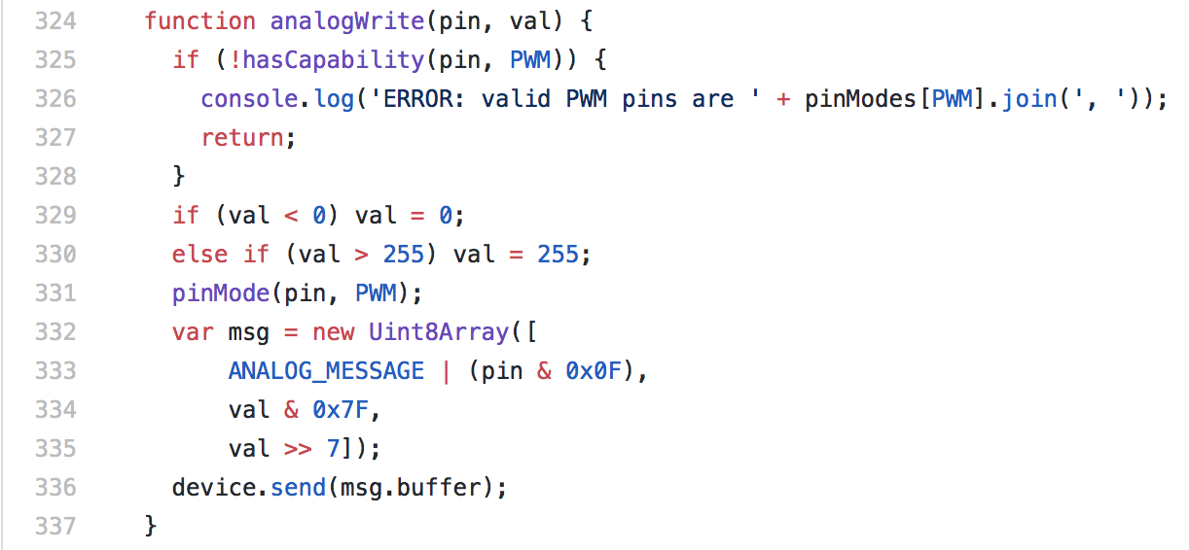

* Problems:
  + Issues with pin numbers rotating the right way (ex. clockwise will turn counterclockwise even though the pin numbers are in the correct place)
  + Analog is not fluid, motor won’t turn at low analogs such as 20 when it should slowly rotate

Move Robot:

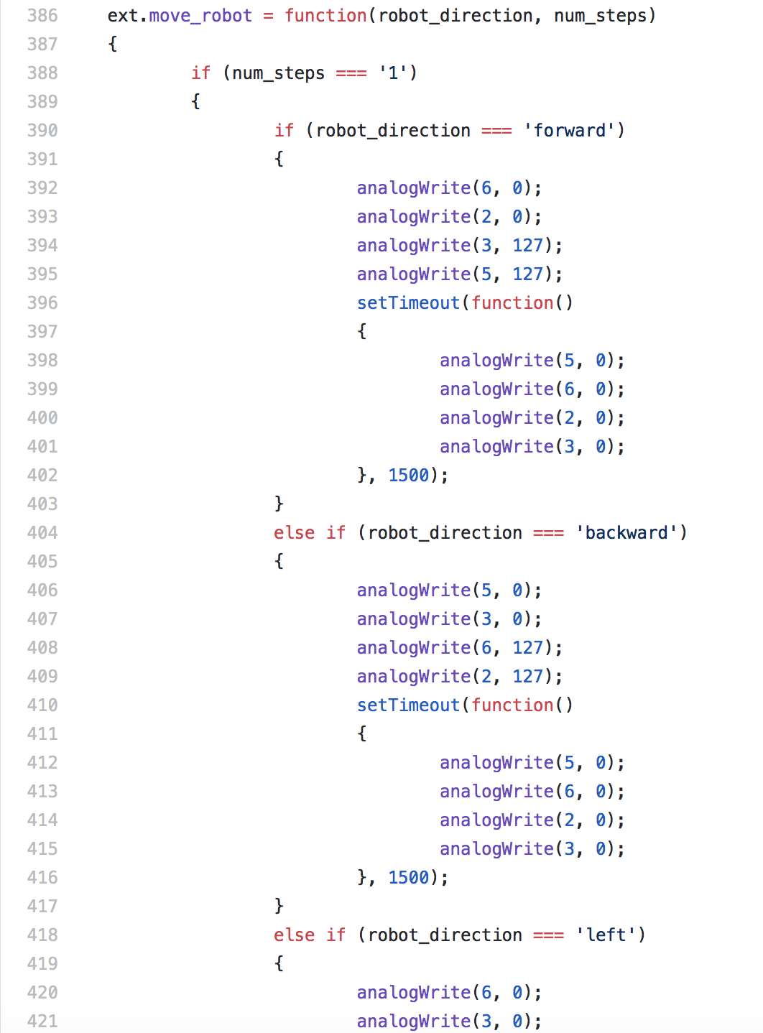



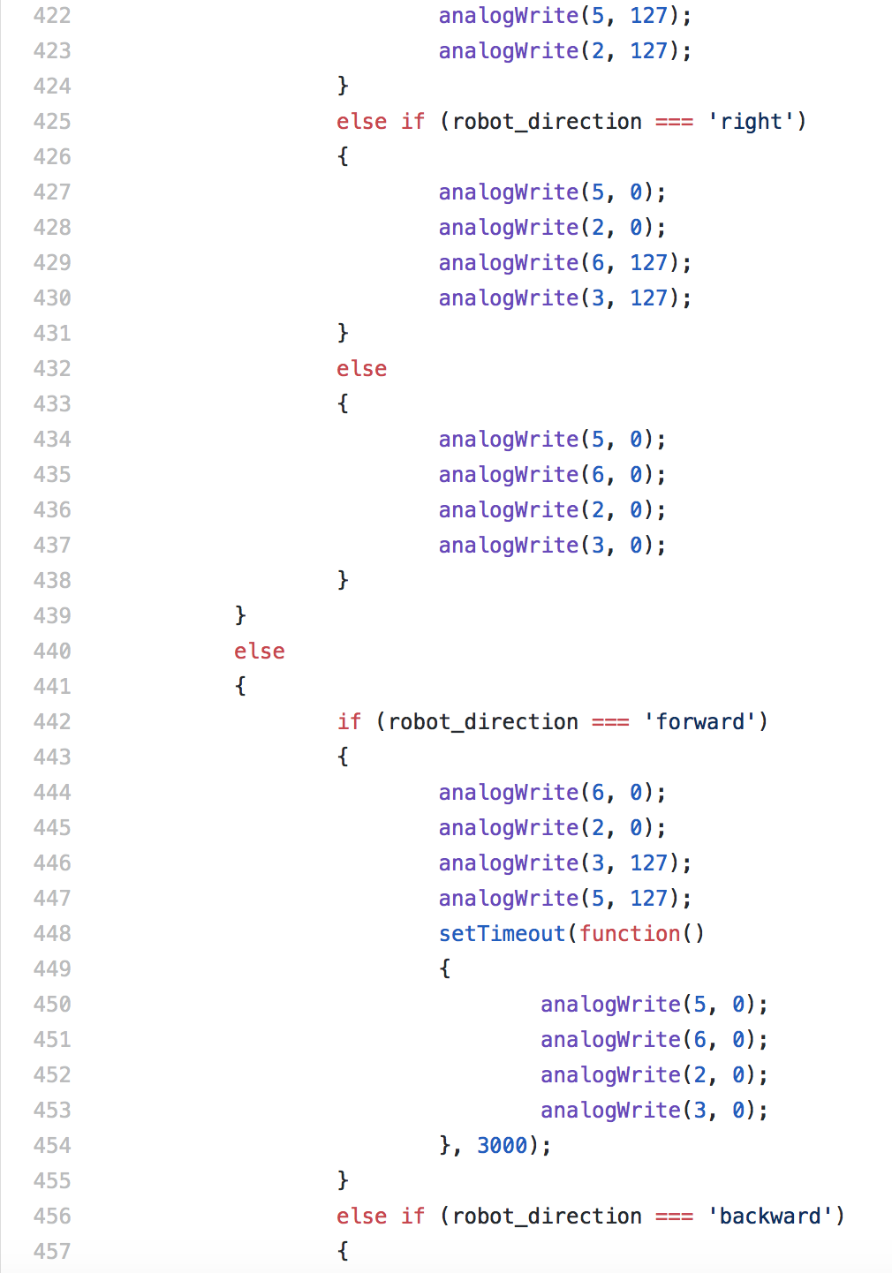

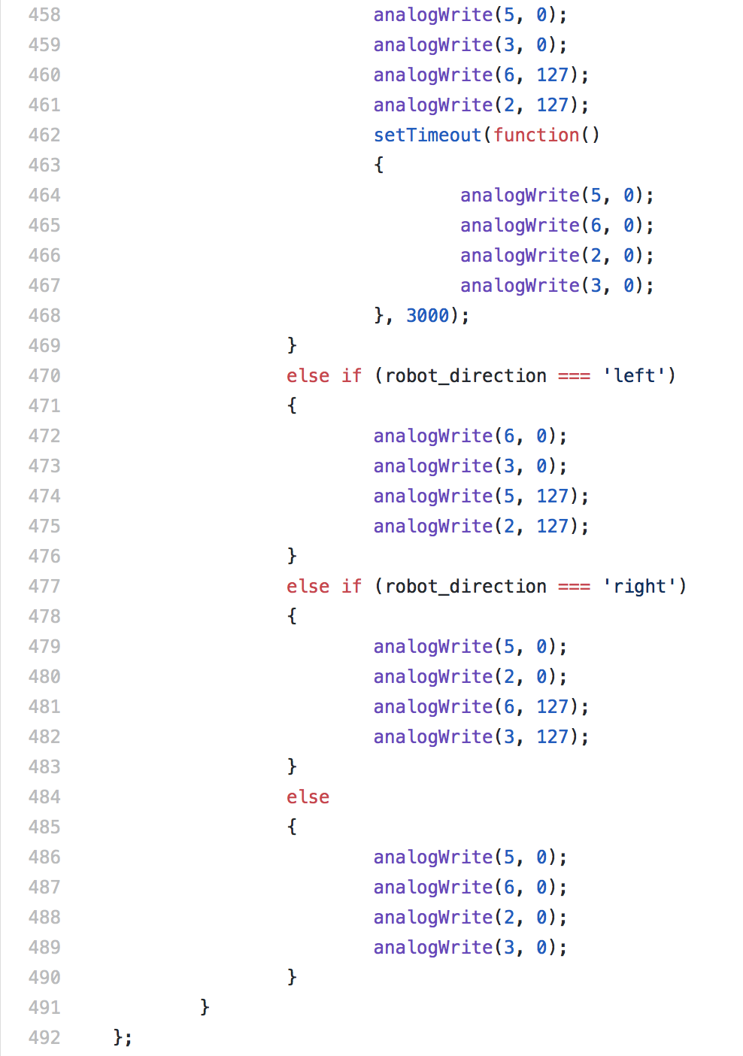



* Function takes 2 inputs from the user; the direction and the number of steps to move.



* The direction allows the user to choose where on the map they want the robot to move. There are 4 options for direction: forward, backward, left and right. The forward/backward commands are the only 2 commands that will allow the robot to move to a different square on the map, as the left and right only turn the robot 90 degrees.
* The number of steps is only used for the forward and backward commands and let the user choose if they want the robot to go 1 of 2 squares in the chosen direction. Before working with the Scratchx extension, the timing that allowed for the robot to accurately move certain number of steps and to accurately turn 90 degrees were discovered through a series of tests through the function blocks that connect to the robot.
* Problems:
  + There is still an issue regarding the timing of the robot’s movements. If you stack multiple blocks together (i.e. move right then forward 2 steps) then the timeouts are not scheduled correctly and it will not perform the correct directions in the correct time
  + However, when using the wait block within controls (already provided by Scratchx) the instructions work perfectly fine

Color LED:

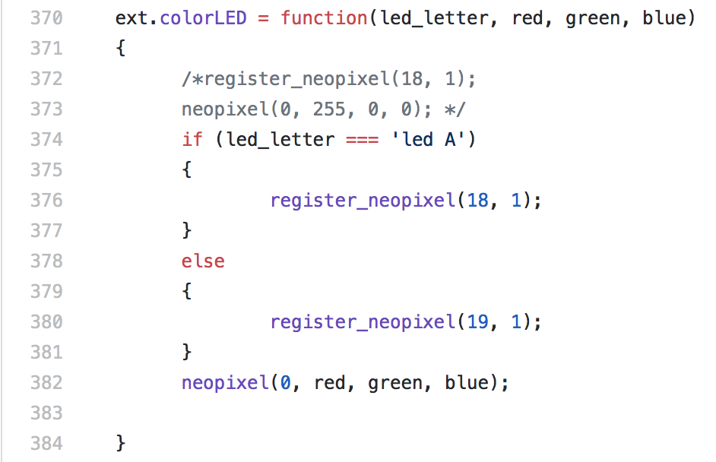

* Function takes 4 inputs from the user: the LED they want to light, and then the measurement of how much red/green/blue the user wants the LED to display.
* Colors are also through an analog from 0-255

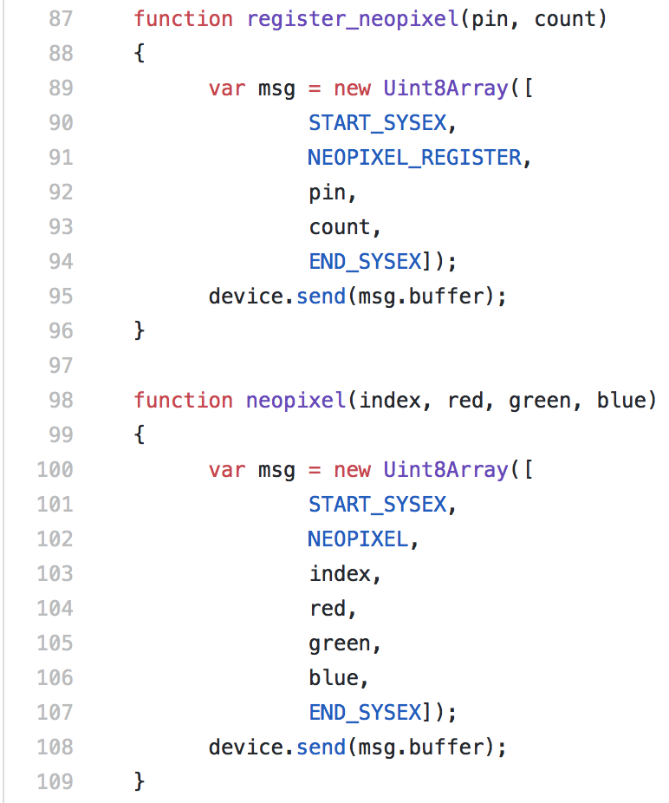

* 2 functions made to connect to a specific port on the microchip in order to display the LED, and to then send the analog information of what color will be displayed. Both functions are used in the colorLED block

